1. Group #: Individual project
2. Names of group members

|  |  |
| --- | --- |
| Names | ID |
| Sumin Han | 20130690 |

1. Research Question

Can we recognize the speaker just by analyzing the sentences in the passage using keywords and their hypernym network?

Currently done research is uploaded in this URL:

<https://github.com/SuminHan/NLP-SpongeBob>

1. Motivation of Research

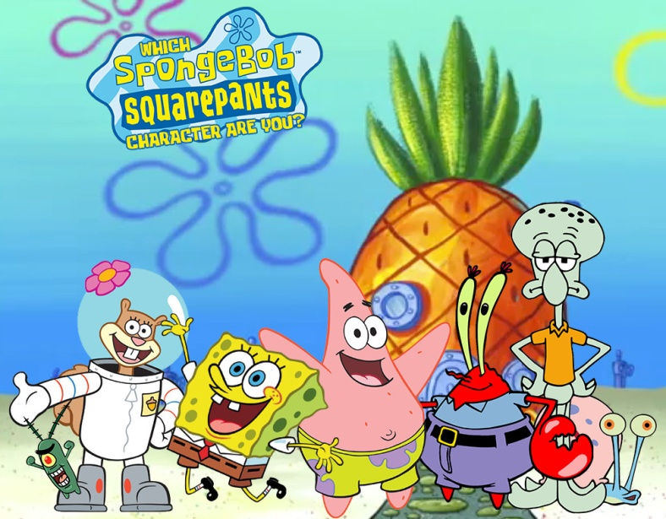

Figure 1. The characters in SpongeBob SquarePants.

I’m a big fan of the animation “SpongeBob” and I watch it almost every day while I’m eating my food. However, I found that in every show, their dialogs are quite similar. For example, Mr. Krabs (the owner of the Krusty Krabs, the fast food restaurant) always talks about the money. SpongeBob, our main character, likes cooking Krabby Patty burgers and loves his personal spatula, and also likes to catch jellyfish as his hobby. Patrick always plays with SpongeBob and gives him a lot of advice when he’s in trouble. Mr. Squidward really hates his job and SpongeBob, but he likes to play his clarinet and art. So I thought that it could be possible to identify the speaker just by analyzing the sentences in the context using the keywords of them.

Also, I conducted a research[1] about the hypernym and their network in another class (Natural Language Processing using python). In that time, I used the Brown corpus and used their organized data. The Brown corpus had 15 categories, so we made the standard ‘popular hypernym tree’. Then we created a metric to find a way to calculate which category is the closest for a random text. However, there were lots of flaws in that research since we were not prudent to make the standard hypernym tree. Also, we only tested for the news articles, so the research was incomplete. In this project, I want to enhance the previous research on the hypernym tree and suggest a better approach for analyzing the speaker or the categorization of the text by analyzing the keywords and the hyper- or hypo-nym relationships between them.

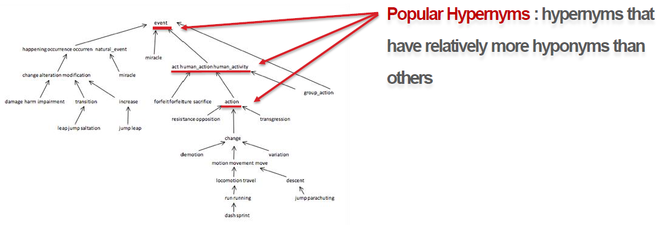

Figure 2. The hypernym tree and extracted the popular hypernyms to make a standard of a certain category to be used for the distance calculation of a random text

1. Corpus/Corpora for this Research

<http://spongebob.wikia.com/wiki/List_of_transcripts>

I’m using the transcripts of SpongeBob series from season 1 to 10, Shorts, Movies, Specials, and Rides. The web page was well organized, so I could crawl all of them by using python code.

1. Methods

* Antconc and TagAnt for the keyword analyzation and tagging the words.
* Python and the NLTK package as the primary tool for programming, making hypernym network.
* Gephi[2], Pajek[3] to draw network and analyze.

1. Expected Results/Conclusions

**Keywords:**

|  |  |
| --- | --- |
| Krabby Patty, spatula, jellyfish, driving license | buddy, friends, play outside |
| money, business | clarinet, art |
| secret, formula, machine, fail | Karate, science |
| meow |  |

**Speaker recognition:**

**Plankton:** Why couldn't I see it before? The way to get the Krabby Patty formula was so obvious! Spend an inordinate amount of time training several dozen sea bears to take over your restaurant and force you to give it up! can turn them from their central purpose!

**SpongeBob:** Yoo-hoo! Who wants their tummies tickled?

**Plankton:** No... My weapons! Ouch!

**SpongeBob:** Sea bears aren't weapons, Plankton. They're furry buckets of love. See? And what do sea bears love more than tummy tickles? Jellyfish honey!

**SpongeBob:** Come and get it!

**Plankton:** No! Come back!

**Mr. Krabs:** Why do you keep doing this, Plankton?

**Plankton:** Heh-heh-heh...

**Mr. Krabs:** When you mess with me business, ya mess with me money!

**Plankton:** Er, money's not everything, you know.

**Mr. Krabs:** 'Course it is! Money makes the world go round, and makes me heart go pound.

1. Implications

If we combine this technology with the voice recognition devices, it could improve the AI to recognize the speaker in the ongoiong conversation and find out the speaker and give him personalized service. For example, somebody said “Mom, I’m hungry” in the middle of the conversation, then the AI may recognize the speaker as the son Mike and bring him Oreo which is his favorite. Recently, many companies like Google, Amazon, Apple, SKT are trying to make a better AI for their voice recognition device, so my research can suggest new approach for the speaker recognition in a context.

1. Similar research

“Identification of Speakers in Fairytales with Linguistic Clues”[4], Hye-Jin Min, Jin-Woo Chung, and Jong C. Park, Language and Information, Vol. 17, No. 2. pp. 93-121, 2013.

This research analyzed the fairytales for the corpus, so there are more narrations than the dialog. My research is based more on the spoken data compared to this research.

1. The paper and the source codes are here: <https://github.com/SuminHan/CS372-Hypernym-Tree>
2. <https://gephi.org/>
3. <http://vlado.fmf.uni-lj.si/pub/networks/pajek/>
4. <http://kiss.kstudy.com/search/download.asp?ftproot=http://210.101.116.16/kiss61/inFTP_Journal.asp&inst_key=9253&a_imag=1m500156.pdf&isDownLoad=1&publ_key=29486>